**EEG Electrodes cont.**

22, 11, 5.5, 2.75mm ECG electrodes

* Print 2 Sets
* Acquire ECG using BIOPACK.
  + Note down their settings.
    - Filters
    - Sample rate
    - Scale
    - Other settings
    - Electrode Configuration
* Analyze the signals.
  + Calculate MSE, MAE, SNR, Cross Corr., Coherence
  + Time domain view (One-two portion) (separate plots, comparison plot)
  + Spectral view (separate plots, comparison plot)
  + Coherence view

|  |  |  |  |  |
| --- | --- | --- | --- | --- |
|  | **22** | **11** | **5.5** | **2.75** |
| **Devinda** |  |  |  |  |
| **Kalana** |  |  |  |  |
| **Kulunu** |  |  |  |  |
| **Hirumi** |  |  |  |  |

**Applied filters:** 0.05 – 100 Hz BP , 50-60 Notch filter

**Sample rate:** 500Hz

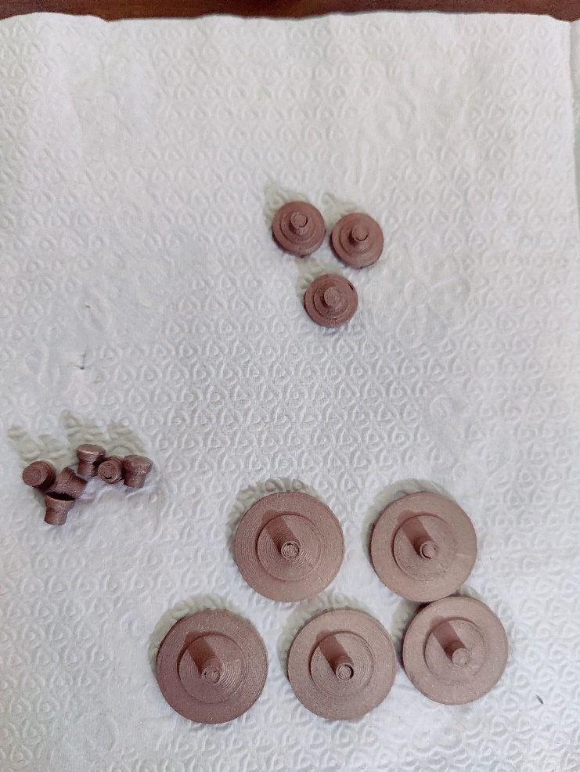**Scale:** 20mV

**Time Scale:** 20s

**Other settings:** Non

**Electrode configuration:** Lead II

**Position** : Resting

**Note** : Biopack ECG practical two use for

the experiment with some modifications

Figure Printed electrodes

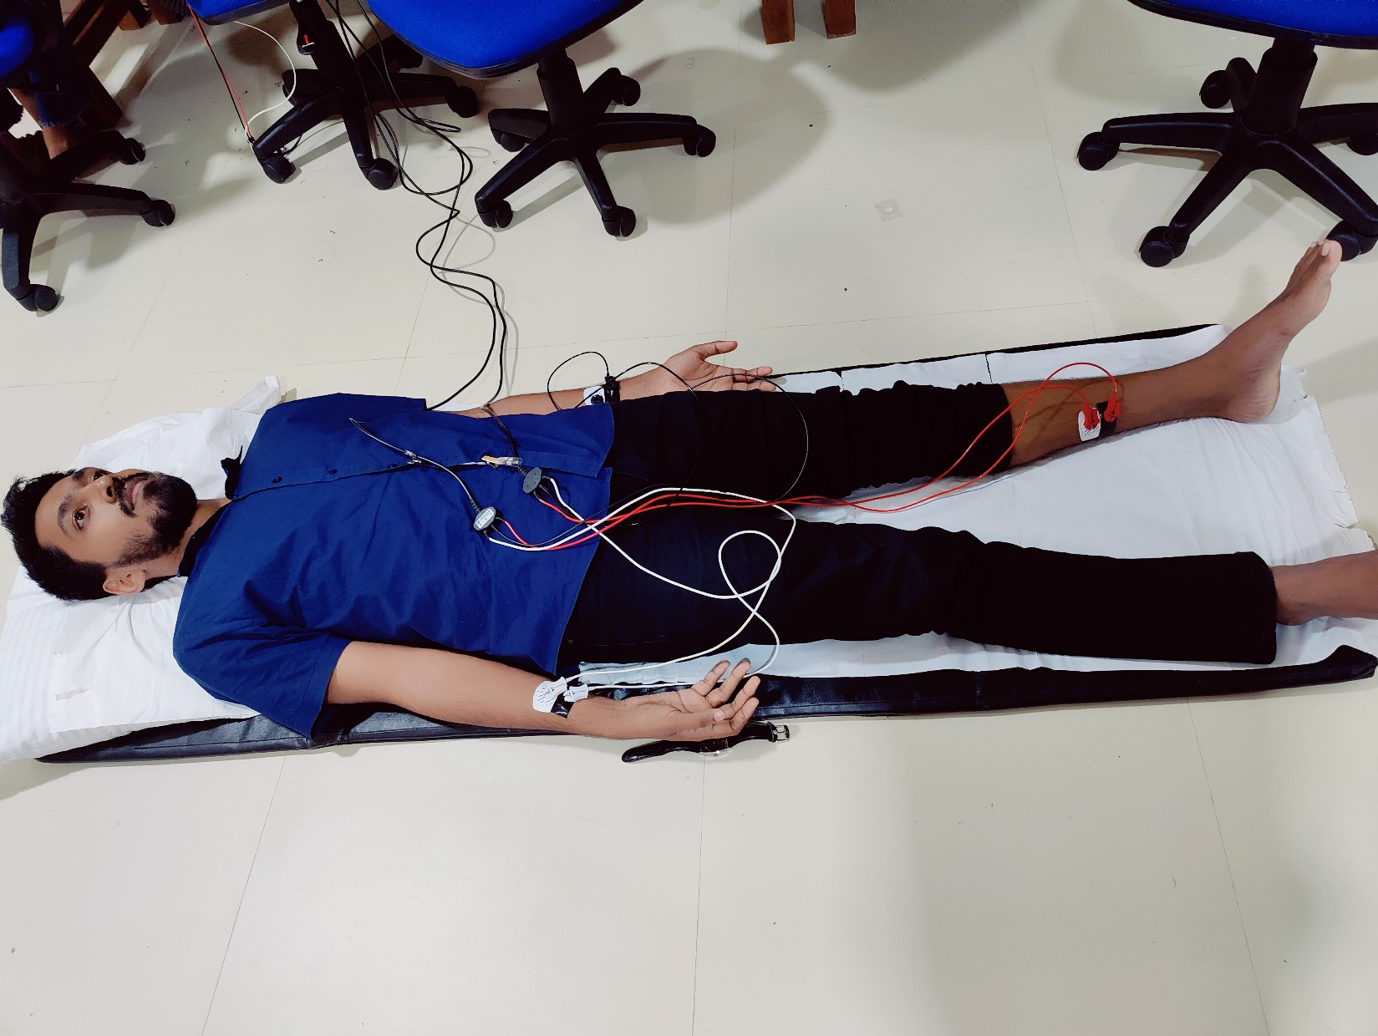**Experimental setup**

Figure Subject 1 at the experiment

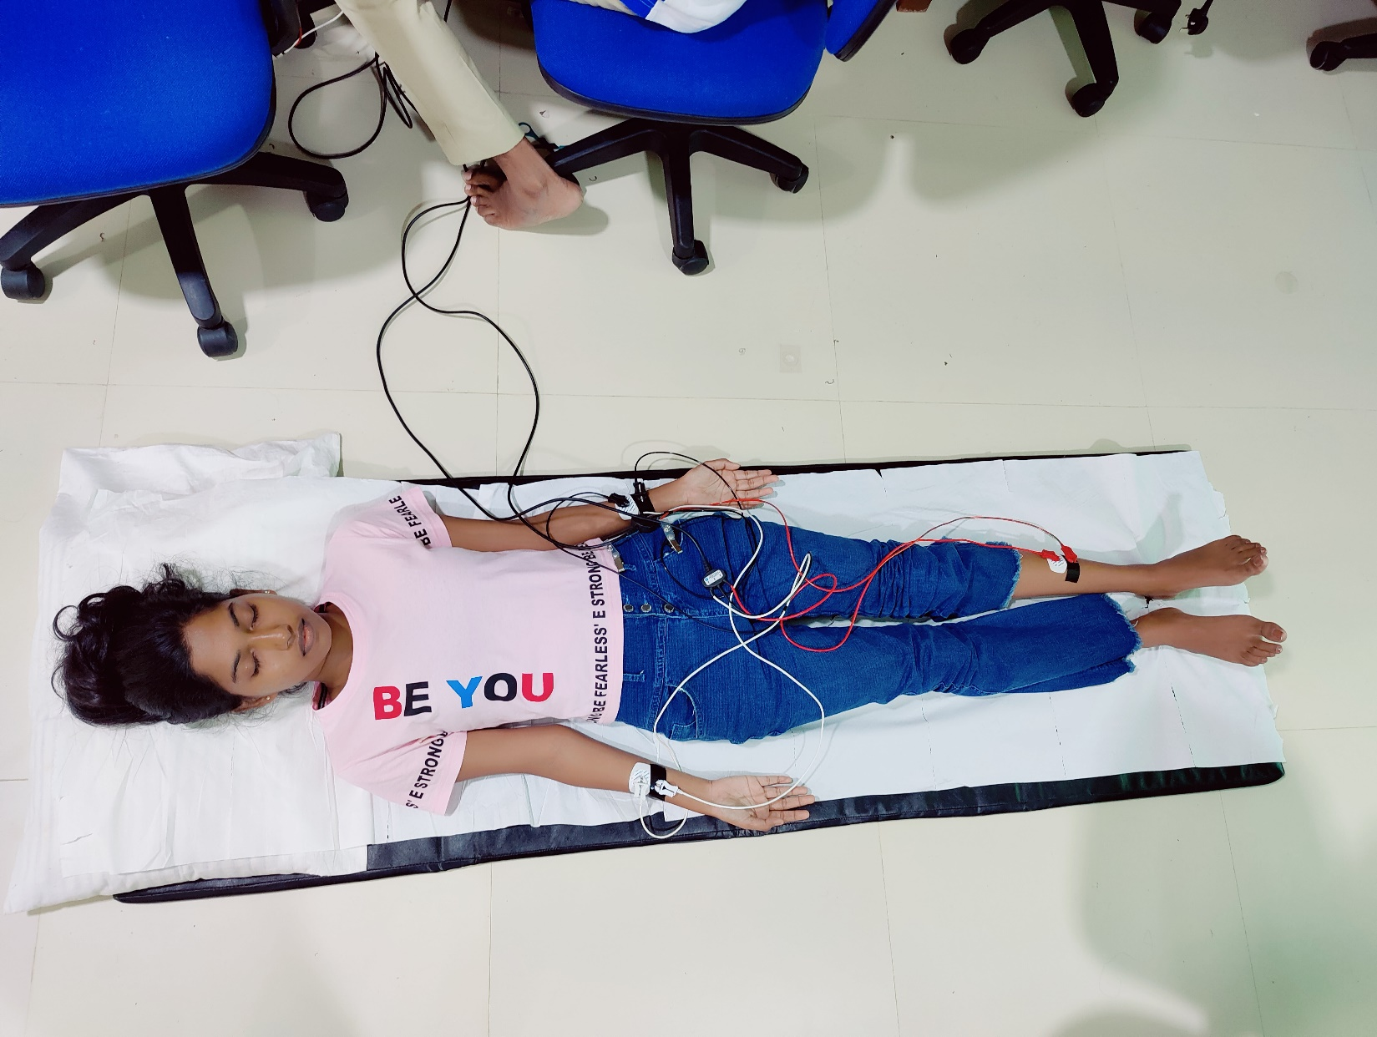

Figure Subject 2 at the experiment

**Results and discussion**

* A picture containing text, screenshot, font, algebra

  Description automatically generatedA picture containing text, screenshot, font, number

  Description automatically generatedFor D = 2.75 mm

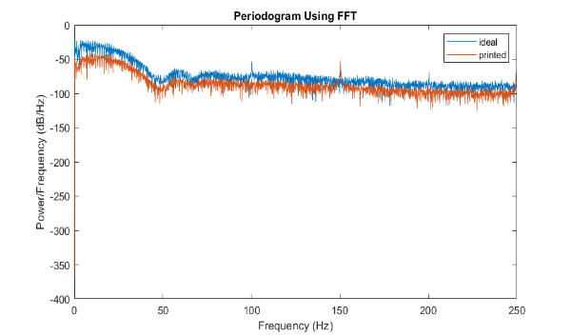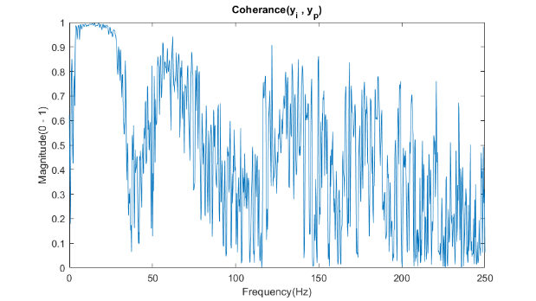

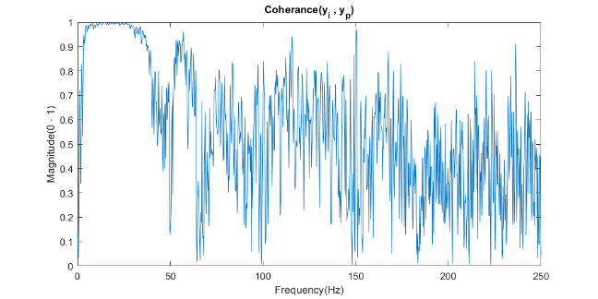

* For D = 5.5 mm

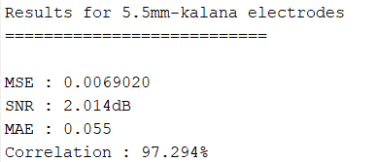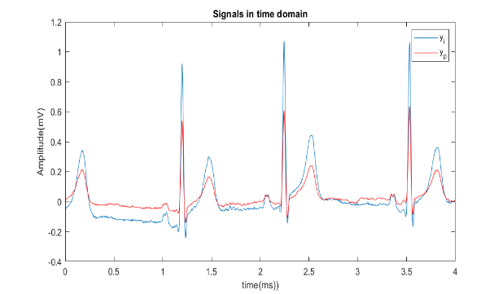

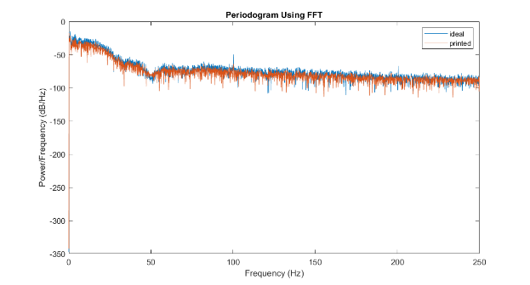

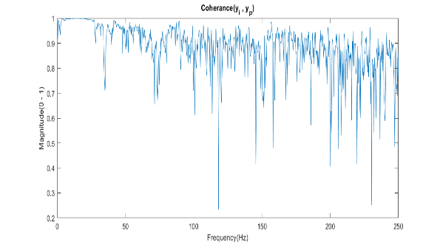

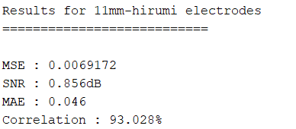For D = 11mm ,

**

For D = 22mm ,

